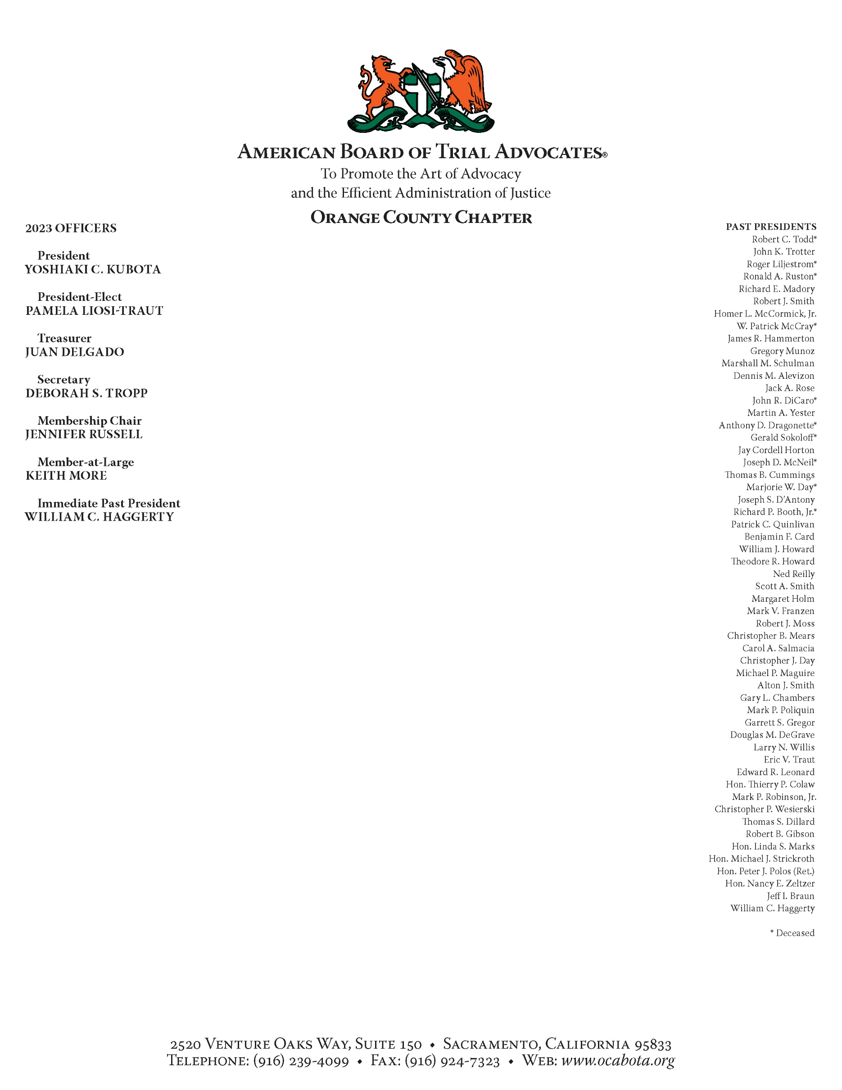

The Orange County Chapter of the American Board of Trial Advocates (ABOTA) Announces The
FALL 2023 SCHOLARSHIP AWARDS FOR THIRD-YEAR LAW STUDENTS

To Be Awarded By
Orange County Chapter of the American Board of Trial Advocates (ABOTA)

APPLICATION DEADLINE: December 8, 2023
The Orange County Chapter of the American Board of Trial Advocates (OC ABOTA) is providing grant monies to law students who are residents of Orange County. Law students meeting the requirements listed below may submit applications until December 8, 2023 to be considered for the Fall 2023 Awards. The first-place recipient will receive $5,000. The second-place recipient will receive $2,500. The third-place recipient will receive $1,000

AWARD ELIGIBILITY REQUIREMENTS:
- The applicant must be in the third year of law school, must be a resident of Orange County, CA, must have demonstrated legal aptitude and must be in good standing at a school of law that is accredited by the State Bar of California.
- The applicant must have a grade point average of at least 3.0 for the past academic year and submit a copy of their transcript for their second year.
- The applicant will prepare and submit an essay which must include the following:
- The reasons why the applicant believes that she or she should receive the OC ABOTA scholarship.
- A discussion on one of the following topics: The importance of the Jury Trial in our justice system or the importance of civility in the legal profession.
- The applicant shall submit his or her curriculum vitae.
- The applicant must submit proof of Orange County residency (including but not limited to a California driver’s license, lease agreement and/or utility bill)
- The applicant will participate in an interview with members of the OC ABOTA Board. The interview may take place in person or electronically based on an assessment of then existing circumstances.
The required transcript, essay and curriculum vitae must be sent by email to Kimberly A. Valentine, Esq. (kvalentine@valentinelawgroup.com) by December 8, 2023
Selection of the Award Recipients will be made on or about January 20, 2024.
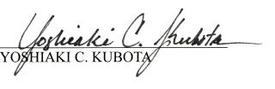

Yoshiaki C. Kubota, Esq. President of OC ABOTA

American Board of Trial Advocates

